Alan Goodman
Professor Boldina
ENG 110-Y13
March 20th, 2026
Paper #2

Don’t Do It: The Real Puppeteers Pulling the Strings
Advertisements have a way of launching us into a state of hyperreality by making us crave and desire products that we know that are not necessary for survival. This not only encompasses marketing products to consumers, but also analyzing trends and how to manipulate feelings into profitable realities. They have a way of connecting with the consumer on a multitude of ways to evoke real, lasting emotions. In the Nike campaign “dream crazier” it made us feel inspired to use their product, while the Lego campaign left us feeling more fearful to not use their product more. “Unrealist expectations, misrepresentation and false images” (Ashley) are just a few of the negative takeaways of an advertisement that James Ashley mentions in his article “Negative and Positive Effect of Advertising.” There will be times when we might get the craving for a particular fast-food chain’s tiny square burgers. This craving makes us go out of our way, and even though we’re not entirely hungry we still order more of these decadent little burgers than you could possibly need. This guttural reflex for excess can leave one feeling negative about one’s self. In Heather Lindsley’s short story “Just Do It” you see the main protagonist, Alex, believe that she is doing everything she can to fight against CraveTech’s new intrusive advertising tactics of now shooting consumers with crave darts. In the end the inevitable happens and Alex is subdued by the blurred lines of reality caused by these darts. These subliminal messages in this story mixed in with the negative effects mentioned are a showcase of the postmodernism we see today in media.

Back in 2019 Nike launched their “dream crazier” campaign in support of women in professional sports to follow up their “dream crazy” campaign a year prior. A part of this campaign is an ad of a young Serena Williams learning how to play tennis early on with the words “it’s only a crazy dream until you do it” coming together with Nike’s classic swoosh and “just do it” slogan. Even though this ad doesn’t highlight any of Nike’s actual products everyone still understands the message that purchasing Nike helps you learn and get better at your craft. This ad is specifically targeting a younger demographic to desire their products. Children will see this young woman learning tennis with the swoosh next to her and beg her parents for anything with the same swoosh on it. This ad decentralizes Serena Williams by using a younger, more unrecognizable version of her making the brand now take over the “hero’s role” in the advertisement making it seem that this child’s success was on the back on Nike alone. One can see the logos persuasive technique displayed mostly within this ad; this is done by not only the positive testimony from Serena presented by Nike. “Until you do it” on the ad itself compliments the natural slogan “just do it” to add an exclamation point on to help build their brand value that much more all while still not displaying a single product. By using Serena as the face of this campaign this appeals to popularity by utilizing the bandwagon effect. If Serena used Nike since she was child to get this far, if I buy my little girl the same Nike products it might help them too!
The “kids shouldn’t watch too much TV” ad put out by Legos was a dark take on the depression and violent natures that are presented on TV and becoming less creative by indulging too much. This image blurs the lines of reality and going into hyperreality by pushing the agenda that TV is to blame for childhood violence that has been a problem within society for a while now. The reality is that playing with Legos does nothing to help the problem that the ad is portraying at its root due to this not being a problem with simply TV. By appealing to consumer’s emotions of fear, it helps drive the target audience, parents, to purchase these sets for their children to be better, happier kids. The persuasive technique that stands out most to myself is the use of ethos, we know that violence is unethical and a problem. By using the shock value image of someone with a gun to their head from being in front of the TV it gives the consumer the social responsibility to buy Lego kits for their children to help them be less depressed and stop being held back by other media forms and put an end to childhood violence and depression. “By addressing the most private psychological needs we can make a powerful connection with our consumers” (Rajnerwicz).
The idea of craving darts that is demonstrated in Heather Lindsley's "Just Do It" blurs the lines of ethics in advertising even further by now chemically inducing humans to crave specific fast-food items. Once those chemicals are in our blood CraveTech has now thrown us in hyperreality by forcing the cravings to not only be ours but also become a forefront in our mind until that craving is satisfied. To double down on this thought CraveTech is looking into BeMod, a way to skip the craving and go straight into the consumer mindset to make a purchase we don't need or desire such as a new hummer. The increase of hyperreality mixed with the idea of commodification, now making it so anything can be marketed with a single dart would most definitely get society caught even more in consumer culture than we already are in without them. The options in which marketers could make you purchase once BeMod hits the shelf are limitless, much like their profits are. Now everything is a sellable commodity, but don't worry CraveTech has us, the consumer, as their priority. That is why for a fee they will now be selling us a reverse formula to end these cravings that are forced on all of us! Even without the darts, every day we fight the urges that advertisements feed on us with the beautiful model endorsing a luxury clothing lines, that superstar tennis player showcasing a swoosh, or a toy line making us feel safe while building their sets. As Alex the protagonist shows, even when we think we are fighting against these tactics that we know are bad unfortunately we are delaying the inevitable satisfaction of ultimately giving in to these cravings and messages. As dystopian this concept is you must ask yourself, how far from reality is this?
“In modernism, reality used to validate media. In postmodernism the media validates reality” (Holland). Advertisements will not be going anywhere anytime soon in the world of business, so it is critical that we try to think past the initial emotions that an ad might make you feel. Every ad we see will appeal to at least one of the many that have been mentioned by Kazimierz Rajnerowicz in “7 Types of Adverting Appeals with Examples” such as the two used in the Nike and Legos ads those being appeal to emotions and popularity. It is up to us to decipher if what we are feeling are truly our emotions or are these feeling being invoked by an advertisement that we recently saw. Though our reality might not be quite as described in “Just Do It”, yet, as imperative that it is that we as consumers stay aware of these subliminal tactics and do everything in our power to take back control of our cravings and desires. Now please, excuse me, I have some decadent little square burgers to get to…

Works Cited
Ashley, James. “Negative and Positive Effects of Advertising”. Medium,com. https://medium.com/@James.Ashley/negative-positive-effects-of-advertising-9242650ae767. February 17th, 2017.
Lindsley, Heather. “Just Do It.” Mspreibish.Com, mspreibisch.files.wordpress.com/2019/09/lc-just-do-it-by-heather-lindsley-2.pdf. July, 2009.
Rajnerowicz, Kazimierz. “7 Types of Advertising Appeals.” Tidio.com. https://www.tidio.com/blog/advertising-appeals/. November 22nd, 2024.
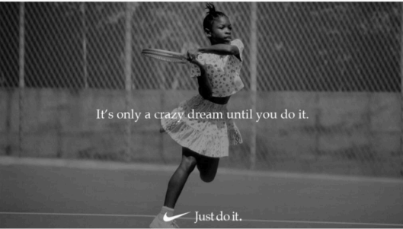
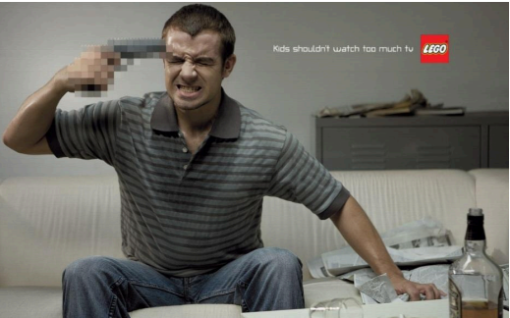
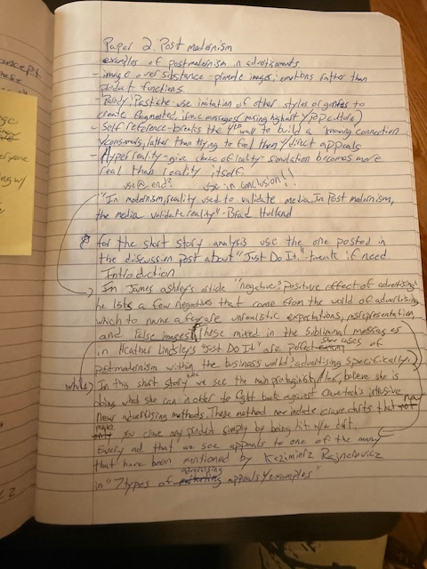
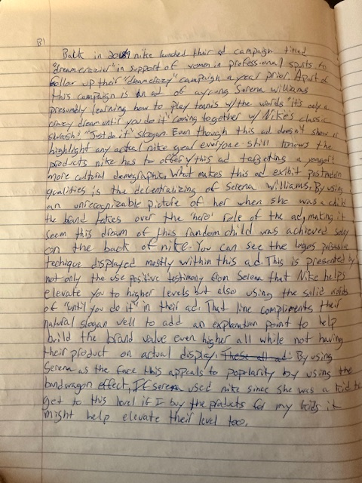
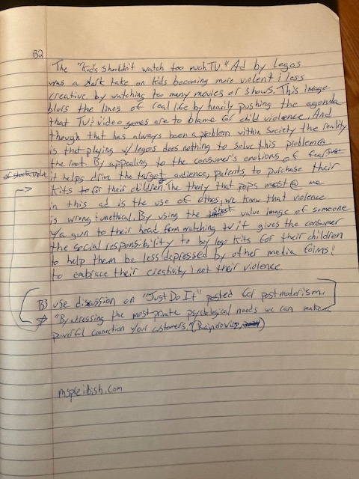
https://d.docs.live.net/75687325c378e1b6/Desktop/Eng%20110/Paper%202/Paper%202%20draft.docx

